EXPERIMENT – 3

Performing Man-in-the-Middle (MITM) Attacks Using Ettercap in Kali Linux

Aim
To perform and analyze a Man-in-the-Middle (MITM) attack using the Ettercap tool in Kali Linux for educational and ethical hacking purposes.

Software Requirements
- Host Operating System: Windows / Linux / macOS
- Virtualization Software: Oracle VirtualBox
- Guest Operating System: Kali Linux
- Security Tool: Ettercap
- System Requirements:
  - RAM: Minimum 4 GB (8 GB recommended)
  - Disk Space: Minimum 30 GB
  - Processor: Intel/AMD with Virtualization support

Introduction
A Man-in-the-Middle (MITM) attack is a type of cyberattack where an attacker secretly intercepts and possibly alters communication between two parties without their knowledge.
Ettercap is a powerful open-source network security tool used for MITM attacks, traffic interception, and protocol analysis.
Using Kali Linux within Oracle VirtualBox provides a controlled and isolated environment to study MITM attacks ethically without affecting real-world systems.

Procedure

Step 1: Start Kali Linux Virtual Machine
- Launch Oracle VirtualBox.
- Start the Kali Linux virtual machine.
- Log in using Kali credentials.

Step 2: Verify Network Connectivity
- Ensure Kali Linux is connected to the same network as the target system.
- Check IP address using:
- ifconfig

Step 3: Launch Ettercap
- Open Terminal in Kali Linux.
- Start Ettercap with graphical interface:
- ettercap -G

Step 4: Select Network Interface
- In Ettercap GUI, click Sniff → Unified Sniffing.
- Select the active network interface (e.g., eth0 or wlan0).
- Click OK.

Step 5: Scan for Hosts
- Click Hosts → Scan for Hosts.
- After scanning, select Hosts → Hosts List.
- Identify the target system and gateway.

Step 6: Configure MITM Attack
- Add the target system as Target 1.
- Add the gateway/router as Target 2.
- Click MITM → ARP Poisoning.
- Enable Sniff remote connections.
- Click OK.

Step 7: Start Sniffing
- Click Start → Start Sniffing.
- Observe intercepted traffic in real time.

Output
- Network traffic between the target system and gateway is intercepted.
- Credentials, packets, and communication details are visible through Ettercap.

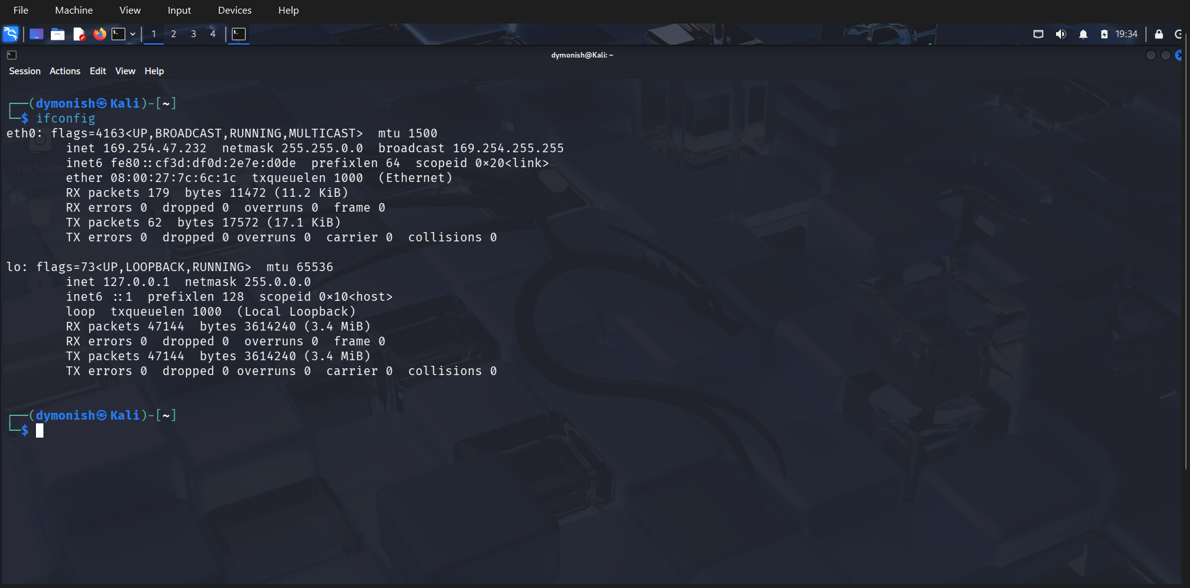

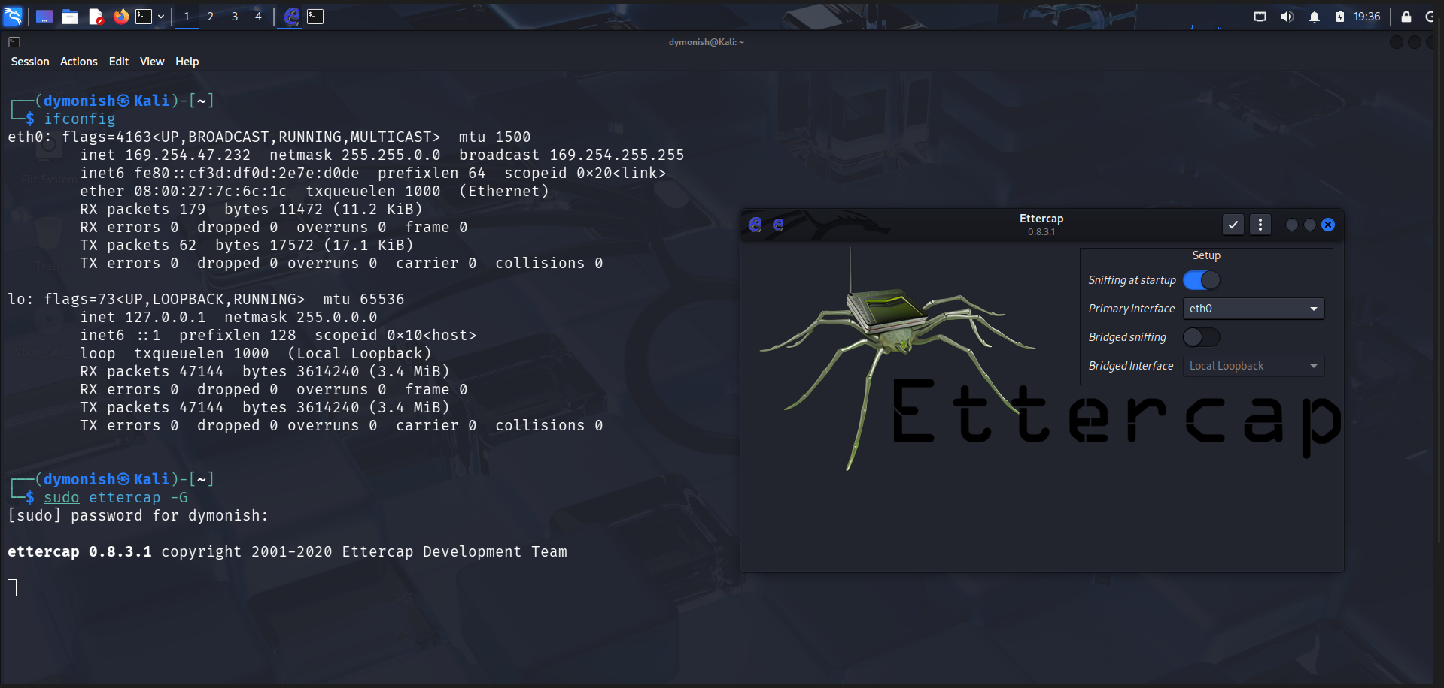

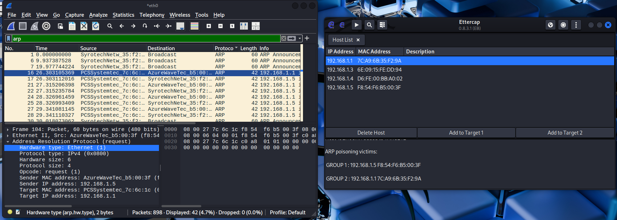

Result
The MITM attack was successfully performed using Ettercap in Kali Linux.
The experiment demonstrated how insecure network communication can be intercepted, highlighting the importance of encryption and secure network protocols.

